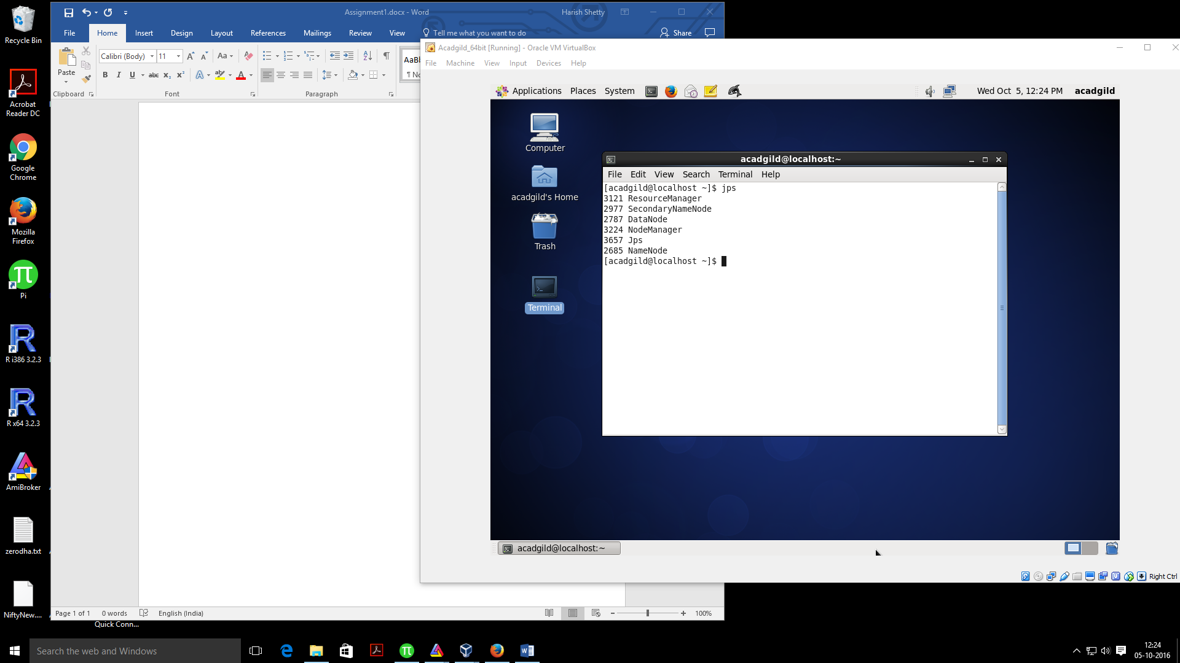

In this assignment you need to install single node Hadoop installation.